DRAFT SAMPLE EXAMINATION
MARKING KEY

2008/20150
CHEMISTRY—ANALYTIC MARKING KEY STAGE 2 PAPER
SECTION ONE

Question No | Answer
1. | B
2. | C
3. | A
4. | C
5. | D
6. | B
7. | A
8. | A
9. | D
10. | A
11. | C
12. | A
13. | C
14. | B
15. | C
16. | A
17. | B
18. | A
19. | C
20. | C
21. | D
22. | B
23. | C
24. | C
25. | A

SECTION TWO- SHORT RESPONSE

Questions 1(a) Fe + CuSO₄ FeSO₄ + Cu [8 marks]
Mark | Description
2 | Student writes the correct molecular formula
1 | Student writes a partial ionic equation
0 | Question answered incorrectly or not at all.

Question 1(b) Pb(NO₃)₂ + Na₂SO₄ PbSO₄ + 2 NaNO₃
Mark | Description
2 | Student writes the correct balanced molecular equation
1 | Student writes an unbalanced or partial ionic equation
0 | Question answered incorrectly or not at all.

Question 1(c) 2 C₄H₁₀ + 13 O₂ 8 CO₂ + 10 H₂O
Mark | Description
2 | Student writes the correct balanced molecular equation
1 | Student writes an unbalanced molecular equation
0 | Question answered incorrectly or not at all.
platinum

catalyst
Question 1 (d) CH₂CHCH₃ + H₂ CH₃CH₂CH₃
Mark | Description
2 | Student writes the correct balanced molecular or structural equation
1 | Student uses an incorrect formula for the hydrocarbon in the molecular equation
0 | Question answered incorrectly or not at all.

Question 2(a) 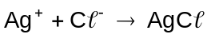 [8 marks]
Mark | Description
2 | Student writes the correct balanced ionic equation
1 | Student correctly identifies change in one reagent
0 | Question answered incorrectly or not at all.

Question 2(b) 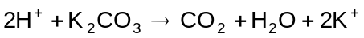
Mark | Description
2 | Student uses H⁺ and a correctly balanced equation
1 | Student uses molecular formula or does not correctly balance the equation
0 | Question answered incorrectly or not at all.

Question 2(c) No reaction
Mark | Description
2 | Student states that there was no reaction
0 | Question answered incorrectly or not at all.

Question 2(d) 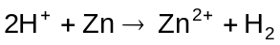
Mark | Description
2 | Student uses H⁺ and a correctly balanced equation
1 | Student uses molecular formula or does not correctly balance the equation
0 | Question answered incorrectly or not at all.

Question 3(a) [8 marks]
Mark | Description
2 | States that bubbles of gas form and calcium carbonate gets smaller or disappears
1 | States only one observation
0 | Question answered incorrectly or not at all.

Question 3(b)
Mark | Description
2 | Students states that a white precipitate forms
1 | Student gives the observation but no colour
0 | Question answered incorrectly or not at all.

Question 3(c)
Mark | Description
2 | Students states that that the solution remains clear, but the solution gets warm
1 | Student states that there is no visible reaction
0 | Question answered incorrectly or not at all.

Question (d)
Mark | Description
2 | The student states that the orange /brown bromine water is decolourised and the organic layer is purple
1 | Student only provides one of the observations
0 | Question answered incorrectly or not at all.

Question 4(a) [9 marks]
Unknown element | Number of protons | Number of neutrons | Electron configuration | Name of the element
X | 12 | 12 | 2, 8,2 | Magnesium
Y | 17 | 17 | 2,8,7 | Chlorine
Z | 17 | 18 | 2,8,7 | Chlorine

Mark | Description
6 | 1 mark for each part of the table correctly answered

Question 4(b)
Mark | Description
3 | Student states that:  - Y and Z are isotopes  - they have the same number of protons and electrons  - they have different number of neutrons.
2 | Student states that:  - Y and Z are isotopes  - they have different number of neutrons.
1 | Student states that:  - Y and Z are isotopes.
0 | Question answered incorrectly or not at all.

Question 5 [4 marks]
Mark | Description
4 | Correctly determines the molecular formula
3 | Calculates empirical mass and determines ratio to match molar mass
2 | Only gets to correctly determining the ratio using mass ratio
1 | Calculates empirical mass
0 | Question incorrectly answered or not attempted.

Empirical formula mass of C₃H₄O₃ = (3x 12.01) + (4x1.008) + (3x16)

= 88.06

Ratio Molecular formula = Formula mass
Empirical formula Empirical mass

= 180 = 2.04
88.06

Molecular formula is 2x empirical formula

2x C₃H₄O₃ = C₆H₈O₆

Question 6 [6 marks]
Species | Electron dot diagram | Mark
methane | 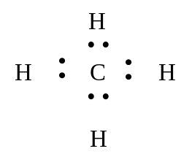 | 2 marks—all electrons are arranged in pairs.
carbon dioxide | O  C  O  • •  • •  • •  • •  •  •  •  •  •  •  •  • | 2 marks—all valence electrons are shown.  1 mark—valence electrons are omitted from oxygen.
potassium chloride | [ K ]  +  C  _  • •  • •  • •  • • | 2 marks—no valence electrons for potassium ion, all shown for chloride ion and both brackets with charges are shown.  1 mark—for only one omission, if more than 1 omission a score of zero

Question 7 [9 marks]
The answers must be within the unit focus and should not have examples such as sodium. The use and related property must match to be given a mark (each response is worth 1 mark).

Bonding type | Name | Use and related property
Covalent molecular | water  ethanol  butane | solvent—able to dissolve polar substances  solvent—able to dissolve oil and grease  fuel—produces energy on reaction with O₂.
Ionic | potassium nitrate | fertiliser—soluble source nitrates for plants.
Covalent network | graphite  silicon dioxide | lubricant—thin 2 dimensional plates  abrasive—hardness of material.

For each bonding type
Mark | Description
3 | 1 mark—names a material that matches the bonding type  1 mark—names a use for that material  1 mark—matches the property to the use
2 | 1 mark—names a material that matches the bonding type  1 mark—names only a use or property for that material
1 | 1 mark—names a material that matches the bonding type
0 | Question incorrectly answered or not attempted.

Question 8 [8 marks]
For each answer
Mark | Description
2 | Names and draws a correct structure
1 | Either correctly draws or names only
0 | Question incorrectly answered or not attempted.

Structural Isomer  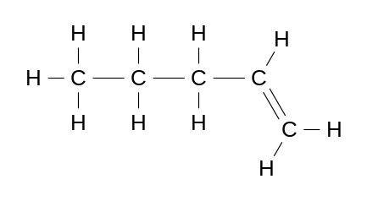  Name: pent-1-ene | Structural Isomer  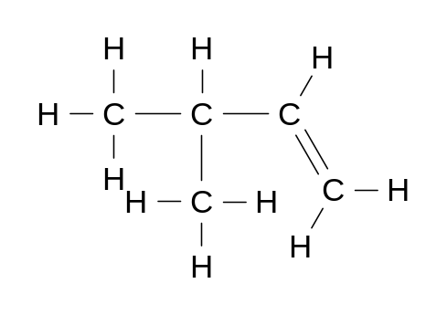  Name: 3–methyl–1–butene
Geometric isomer  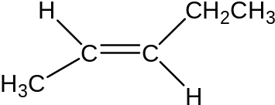  Name: trans–2–pentene | Geometric isomer  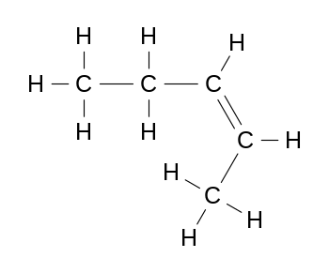  Name: cis–2–pentene

Question 9(a) [7 marks]
Mark | Description
2 | Na⁺ + e– à Na
1 | One error in equation
0 | Question answered incorrectly or not at all.

Question 9(b)
Mark | Description
2 | 2Br– à Br₂ + 2e–
1 | One error in equation
0 | Question answered incorrectly or not at all.

Question 9(c)
Mark | Description
2 | Correctly shows the direction of sodium and bromide ions
1 | Only shows the electron flow at one of the electrodes
0 | Question incorrectly answered or not attempted.

Question 9(d)
Mark | Description
2 | Correctly shows the direction of electron flow from the anode and into the cathode as shown in the diagram
1 | Shows the ions moving in the opposite directions to those shown in the diagram
0 | Question incorrectly answered or not attempted.

Question 10(a) [5 marks]
Mark | Description
2 | Saturation refers to the bonding in the hydrocarbon chain. Saturated compounds all have single covalent bonds in the hydrocarbon chain, while unsaturated compounds have at least one double bond in the hydrocarbon chain
1 | The answer is in terms of the presence of double and single bonds but the location of the bonds is not mentioned
0 | Question incorrectly answered or not attempted.

Question 10(b)
Mark | Description
1 | The structure has more than one double bond in the structure or chain
0 | States that the structure has double bonds or incorrectly answers the question.

Question 10(c)
Mark | Description
2 | Describes an appropriate test, such as the decolourisation of iodine water or bromine water and includes correct observations
1 | Describes the correct test, but the observations are not included or are incorrect
0 | Question incorrectly answered or not attempted.

Question 11(a) [5 marks]
PV = nRT at STP P = 101.3kPa
T = 273 K
R = 8.314
and V = 0.0447 L

n = PV = 101.3 x 0.0447
RT 8.314 x 273

n = 1.99 x 10 ⁻³
Mark | Description
2 | Correctly determines the number of moles of hydrocarbon
1 | Calculates an incorrect value due to not converting the volume to litres or uses the incorrect value of R
0 | Question incorrectly answered or not attempted.

Question 11(b)
formula mass = mass = 0.112
N 1.99 x 10 ⁻³

formula mass = 56.1
Mark | Description
1 | Correctly determines the formula mass
0 | Question incorrectly answered or not attempted.

Question 11(c)
Given that the empirical formula is CH₂ and for this exercise let
C = 12 and H = 1, then by a process of trial and error:

When the number of carbons = 4, and number of H = 4
the molecular mass = 56.

The molecular formula of the unknown compound is C₄ H₈.
Mark | Description
2 | Correctly determines the number of carbons and hydrogen that will give a molecular mass of 56
1 | Only calculates the empirical mass of 14
0 | Question incorrectly answered or not attempted.

SECTION THREE—EXTENDED RESPONSE

Question 1(a) [12 marks]
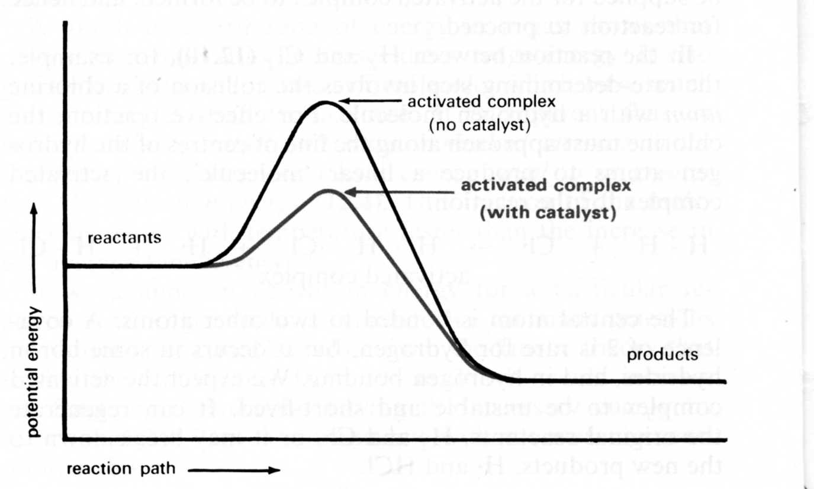
Catalysed pathway
∆H
Activation energy

Potential energy
Reaction coordinate

Question 1(a)(i)
Mark | Description
4 | The student correctly labels:  - activation energy  - ΔH  - both axes  - reaction profile has the correct shape
3–1 | The student gets one mark for each point correctly addressed
0 | Question incorrectly answered or not attempted.

Question 1(a)(ii)
Mark | Description
1 | Correctly shows that a catalyst lowers the activation energy
0 | Question incorrectly answered or not attempted.

Question 1(b)
Mark | Description
2 | The two conditions are:  - increased temperature  - excess methanol.
1 | Only mentions one of the correct conditions
0 | Question incorrectly answered or not attempted.

Question1(c)(i) Increasing the temperature increases the number of molecules with energy greater than the activation energy. The probability of a successful collision increases and the rate of reaction increases.

Question 1(c)(ii) Increasing the concentration increases the probability of a collision between the reactant molecules. The increase in collision frequency will increase the rate of collision.

Mark | Description
2  each  (4) | Both conditions  - increased temperature  - excess methanol  are mentioned and their effect on the rate of reaction is explained
1 | Only explains the effect of one of the correct conditions
0 | Question incorrectly answered or not attempted.

Question 1(d)
Mark | Description
1 | The student recognises that sodium hydroxide is a strong base and needs to be handled with care
0 | Question incorrectly answered or not attempted.

Question 2(a)(i) [11 marks]
Mark | Description
2 | States two appropriate variables, including:  - mass of catalyst  - volume of hydrogen peroxide  - temperature of system
1 | One appropriate variable given
0 | Question incorrectly answered or not attempted.

Question 2(a)(i)
Mark | Description
2 | States time and one of two appropriate variables:  - loss of mass  - volume of oxygen produced
1 | States two variables but does not include time
0 | Question answered incorrectly or too little information given.

Question 2(b)(i)

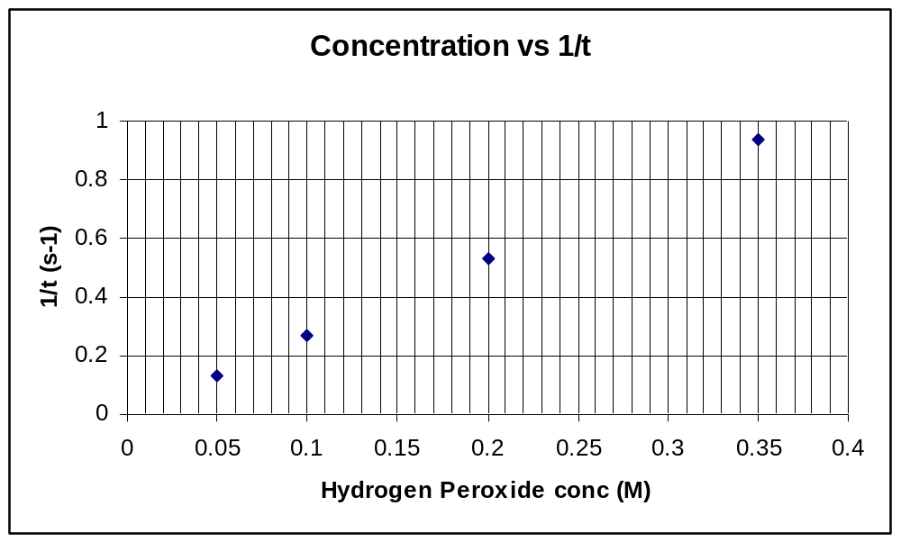

Mark | Description
5 | All categories given:  - all axes labelled correctly  - correct units on axes titles  - points plotted correctly  - line of best fit  - graph title
4 | 4 of the five categories given, including line of best fit
3 | 3 of the five categories given, but no line of best fit
2 | 2 of the five categories given
1 | 1 of the five categories given
0 | Question answered incorrectly or not at all.

Question 2(b)(ii)
Mark | Description
2 | As the concentration of hydrogen peroxide increases the rate of reaction increases.  There is a direct relationship between the concentration of hydrogen peroxide and the rate of reaction
1 | As the concentration of hydrogen peroxide increases the rate of reaction increases.  OR  There is a direct relationship between the concentration of hydrogen peroxide and the rate of reaction

Question 3(a ) [12 marks]
3 Pb(NO₃)₂ + A₂(SO₄)₃ 3 PbSO_{4(s)} + 2A(NO₃)₃
Mark | Description
2 | Student writes the correct balanced molecular equation
1 | Student uses the correct molecular formula but fails to balance the equation
0 | Question answered incorrectly or no equation.

Question 3(b)
Moles of lead nitrate = 2.62 Formula mass Pb(NO₃)₂ = 269.21
269.21

= 9.732 x 10⁻³

Moles of PbSO_{4(s)} = 9.732 x 10⁻³ Formula mass PbSO4_{(s)} = 303.26

Mass of PbSO_{4(s)} = 9.732 x 10⁻³ x 303.26

= 2.95 g

Mark | Description
3 | Correctly calculates mass of precipitate
2 | Makes one simple error, but uses correct procedure
1 | Calculate moles from mass
0 | Question answered incorrectly or not at all.

Question 3(c)
n = c x v
1000

= 0.132 x 55
1000

= 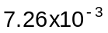

Mark | Description
2 | Student correctly calculates the number of moles of aluminium sulfate
1 | Student obtains an incorrect value due to not converting the volume to litres
0 | Question answered incorrectly or not at all.

Question 3(d)
From the equation 3 Pb(NO₃)₂ + A₂(SO₄)₃ 3 PbSO_{4(s)} + 2A(NO₃)₃

3 moles of Pb(NO₃)₂ reacts with 1 mole of A₂(SO₄)₃

9.732 x 10⁻³ moles of Pb(NO₃)₂ will react with 3.32 x 10⁻³ (9.732 x 10⁻³ 3) moles of
aluminium sulfate.
The limiting reagent is Pb(NO₃)₂ because there is an excess of aluminium sulfate.
i.e. 3.32 x 10⁻³ moles of aluminium sulfate needed, but moles available.

Mark | Description
3 | The student uses the stoichiometric ratio to identify the limiting reagent
2 | The student identifies the correct limiting reagent but does not show sufficient working
1 | The student calculates the number of moles of each reagent but does not take the stoichiometric ratio into account when identifying a limiting reagent
0 | Question answered incorrectly or not at all.

Question 3(e) Yes - In both cases the aluminium sulfate is the excess reagent and the 2.62g of lead nitrate would precipitate out as lead sulfate.

Mark | Description
2 | The student uses the information from (d) to support their answer
1 | The student did not select lead nitrate as the limiting reagent, but if their answer supports their selected limiting reagent then full marks will be awarded
0 | Question answered incorrectly or not at all.

Question 4(a)
Moles of NH₃ [12 marks]

PV = nRT

n = PV
RT

= 101.3 x .0.5081
8.315 x 273

= 2.27x 10⁻³ moles of NH₃

Mark | Description
2 | Calculates correct number of moles of ammonia
1 | Calculates a value, does not use the correct volume or value for R
0 | Question incorrectly answered or not attempted

Question 4(b) Mass of NH₃

n = mass
formula mass

mass NH₃ = 2.27x 10⁻³ x (14 + (3x1.008))

= 0.386 g
Mark | Description
2 | Calculates the correct mass of ammonia
1 | Calculates a value, but makes one error in calculation
0 | Question incorrectly answered or not attempted

Question 4(c) Mass of water = mass of complex salt - mass of copper sulfate
and ammonia

= 1.4009 - 0.9055

= 0.4954 g

Mass of water = Mass of ammonia and water - mass of ammonia

= 0.4954 - 0.386 g

= 0.1094g
Mark | Description
3 | Calculates mass loss correctly, recognising that this is a twostep process
2 | Gives mass of water without workings
1 | Calculates mass of water and ammonia
0 | Question incorrectly answered or not attempted.

Question 4(d) Moles of water = 0.1094
in the sample 18.016

= 6.072 x 10⁻³
Mark | Description
1 | Correctly converts mass of water to moles of water
0 | Question incorrectly answered or not attempted.

Question 4(e) Moles of copper = 0.9055
sulphate 159.5

⁼ ^{5.677 x 10}-3
Mark | Description
1 | Correctly converts mass of copper sulfate to moles of copper sulfate
0 | Question incorrectly answered or not attempted.

Question 4(f)
Empirical moles CuSO₄ moles NH₃ moles H₂O
formula 5.677 x 10⁻³ 2.267x 10⁻³ 6.072 x 10⁻³

mole ratio 1 3.99 1.06

Empirical
formula CuSO₄ (NH₃)₄ .H₂O
Mark | Description
3 | Calculates the correct empirical formula
2 | Calculates an empirical formula using incorrect value/s from (a) – (e)
1 | Attempts empirical formula, unable to get whole number ratio
0 | Question incorrectly answered or not attempted.

Question 5(a)(i) [13 marks]
CaO + H₂O Ca(OH)₂
Question 5(a)(ii)
CaCO₃ CaO + CO₂
Mark | Description
4 | Correctly balances both equations
2 | Correctly writes one balanced equation
0 | Question incorrectly answered or not attempted.

Question 5(b) If water was used in an attempt to extinguish the burning magnesium alloy wheels the water would decompose producing hydrogen producing a fuel that will burn. Using carbon dioxide to suffocate the burning magnesium alloy wheels will not work because magnesium will burn in a carbon dioxide atmosphere unlike other most other fuels
Mark | Description
3 | Student explains that water produces a product that burns and explains why carbon dioxide is not suitable
2 | The student gives reasons why water and carbon dioxide are not suitable
1 | The student only discusses one method
0 | Question incorrectly answered or not attempted.

Question 5(c)
Anode reaction: 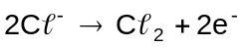 [2 marks]
Cathode reaction: 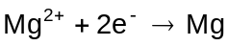 [2 marks]
Mark | Description
4 | Correctly shows the direction of movement of the ions inside the electrolytic cell and writes balanced anode and cathode reactions
3 | The student correctly shows the movement of both ions, but only balances one of the reactions
2 | The student only balances the equations or only shows the movement of ions or balances one equation and shows the movement of one ion
1 | The student only shows the direction of the movement of the ions or only balances one equation
0 | Question incorrectly answered or not attempted.

Question 5(d)
Mark | Description
2 | Aluminium has a low atomic mass while copper and manganese have higher atomic masses
1 | The resulting alloy should be as light as possible, so aluminium is preferred to heavier metals.

CHEMISTRY
Sample external written examination
Stage 2
Mapping questions to content
Course  content ü | Macroscopic properties of matter | Atomic structure and bonding | Chemical reactions | Acids and bases in aqueous solutions | Oxidation and reduction | Organic Chemistry | Applied  chemistry
Section 1 – Multiple-choice
Question
1 |  |  |  | ü |  |  |   | - qualitatively apply the pH scale
2 |   |  |  |  | ü |  |  | - calculate oxidation numbers
3 |   | ü |  |  |  |  |  | - explain the formation of positive and negative ions for elements in groups 1, 2 and 13–18
4 | ü  |  |  |  |  |  |  | - explain the differences between concentrated and dilute solutions of strong and weak electrolytes
5 |   | ü |  |  |  |  |  | - describe and explain the relationships between properties and structures of ionic, metallic, covalent network and covalent molecular substances
6 | ü |  |   |  |  |  |  | - vapour pressure and factors that affect vapour pressure
7 |  |   | ü |  |  |  |  | - apply the concepts of system and surroundings to energy transfer
8 |  |   | ü | ü |  |  |  | - identify and apply the factors affecting rates of reaction
9 | ü |  |  | ü |  |  |  | - describe and explain the difference between strong acids including HCl, H₂SO₄, HNO₃ and weak acids including CH₃COOH and H₃PO₄
10 |  |   |  |  | ü |  |  | - identify oxidation-reduction reactions using oxidation numbers
11 |  |  |   |  |  | ü |  | - write observations and equations for:  - addition reactions with halogens and hydrogen
12 | ü |  |   |  |  |  |  | - predict the effect on gases of changes in pressure, temperature and volume (qualitative only)
13 |  | ü |   |  |  |  |  | - describe and explain the formation and characteristics of:  - ionic bonds and ionic substances  - metallic bonds and metallic substances  - covalent bonds  - covalent network and molecular substances
14 | ü |   |  |  |  |  |  | - apply solubility rules to predict if a precipitate will form
15 |  |  |  |   |  | ü |  | - Alkenes:  - name and draw straight and simple branched to C₈ (only one double bond per structure)
16 |  | ü |  |   |  |  |  | - describe and explain the formation and characteristics of:  - ionic bonds and ionic substances  - metallic bonds and metallic substances  - covalent bonds  covalent network and molecular substances
17 |  |  |  |   | ü |  |  | - identify oxidation-reduction reactions using oxidation numbers
18 |  |  |  | ü  |  |  |  | - identify acids by:  - indicator colour
19 |  | ü |  |   |  |  |  | - explain the relationship between the number of valence electrons and chemical properties of elements in groups 1, 2 and 13–18
20 |  | ü |  |  |   |  |  | - describe and explain the relationships between properties and structures of ionic, metallic, covalent network and covalent molecular substances
21 |  |  |  | ü |   |  |  | - describe, explain and apply an understanding of the Arrhenius and Brønsted-Lowry models of acids and bases
22 |  | ü |  |  |   |  |  | - describe and explain the relationships between properties and structures of ionic, metallic, covalent network and covalent molecular substances
23 |  | ü |  |  |  |   |  | - explain the relationship between the number of valence electrons and chemical properties of elements in groups 1, 2 and 13–18
24 | ü |  | ü |  |  |   |  | - identify and apply the factors affecting rates of reaction:  - concentration  - catalysts  - temperature  - state of sub-division
25 |  |  |  |  |  | ü  |  | - explain the diversity of carbon-based compounds
Section 2
1 | ü |  |   |  | ü | ü |  | - apply solubility rules to predict if a precipitate will form when two dilute ionic solutions are mixed (see data sheet)  - describe, write equations for and interpret observations for:  - metal displacement reactions  - write observations and equations for:  - addition reactions with halogens and hydrogen
2 | ü |  |   | ü |  |  |  | - apply solubility rules to predict if a precipitate will form when two dilute ionic solutions are mixed (see data sheet)  - reaction with:  - metal carbonates and hydrogen carbonates
3 |  |   |  | ü | ü | ü |  | - reaction with:  - metal carbonates and hydrogen carbonates  - metal hydroxides  - halogen displacement reactions
4 |  | ü |   |  |  |  |  | - identify elements using their atomic number (Z)  - explain isotopes using their atomic number (Z) and mass number (A)
5 |  |  | ü |  |   |  |  | - molecular formulae from empirical formula and molar mass
6 |  | ü |  |   |  |  |   | - draw representations of molecular and ionic substances using electron dot (octet only) or Lewis structure diagrams
7 |  | ü |  |  |  |   | ü | - describe and explain the relationships between properties and structures of ionic, metallic, covalent network and covalent molecular substances
8 |   |  |   |  |  | ü |  | - draw and name structural and geometric isomers
9 |  |  |  |  | ü |   |  | - predict and name the electrode products for the electrolysis of molten metal halides only
10 |  |  |   |  |  | ü |  | - write observations and equations for:  - addition reactions with halogens and hydrogen
11 |  |  | ü |  |  |  |  | - molecular formulae from empirical formula and molar mass  - use molar volume of gases at STP in calculations involving the evolution of gases
Section 3
1 |   |  | ü  |  |  |  | ü | - interpret and explain enthalpy diagrams and equations that include the heat lost or gained (ΔH)  - explain the relationship between collision theory, kinetic energy distribution graphs and the rate of a reaction
2 |  |  | ü  |  |  |  |  | - describe the rate of a reaction in terms of rate of change of a measurable quantity with time  - identify and apply the factors affecting rates of reaction:  - concentration  - catalysts  - temperature  - state of sub-division
3 | ü  |  | ü |  |  |  |  | - perform stoichiometric problems that interrelate mass, molar mass, number of moles of solute, and concentration and volume of solution  - limiting reagent
4 |  |  | ü  |  |  |  |   | - use molar volume of gases at STP in calculations involving the evolution of gases  - mass to mole  - empirical formula calculations using percentage composition, mass composition and combustion data
5 |  |  | ü |  | ü |  | ü | - electrode product prediction for molten metal halides only  - describe electro-winning and electro-refining

